Fiddler Costumes: These are VERY conservative people. There should be no exposed skin. Costumes should be e-mailed to Ms. Levy at r4levy@bellmore-merrick.k12.ny.us by Feb. 25th. Ask around before buying things. If there’s a monetary issue at home, please notify Ms. Levy ASAP, so the drama club can assist you.

Mothers and Daughters: Solid color peasant skirt, buttoned shirt, head scarf (Mamas, your hair must be contained inside the scarf. Daughters, the scarf should be tied around your head with hair exposed in the back), a colored apron, and character boots
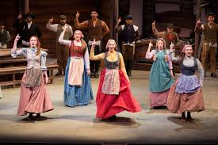
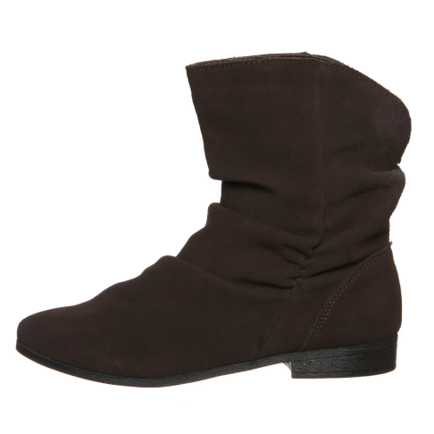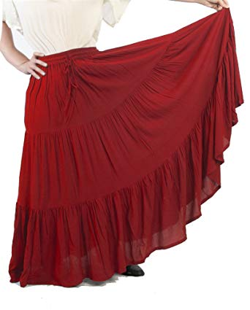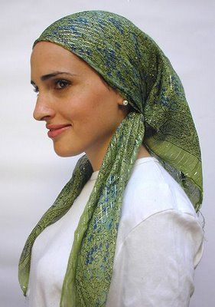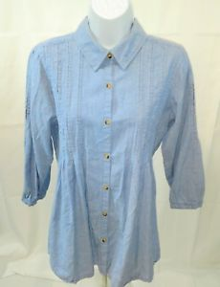
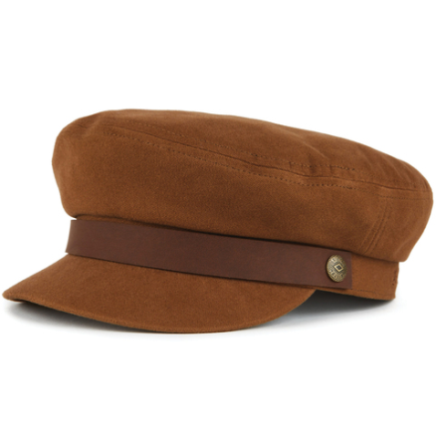
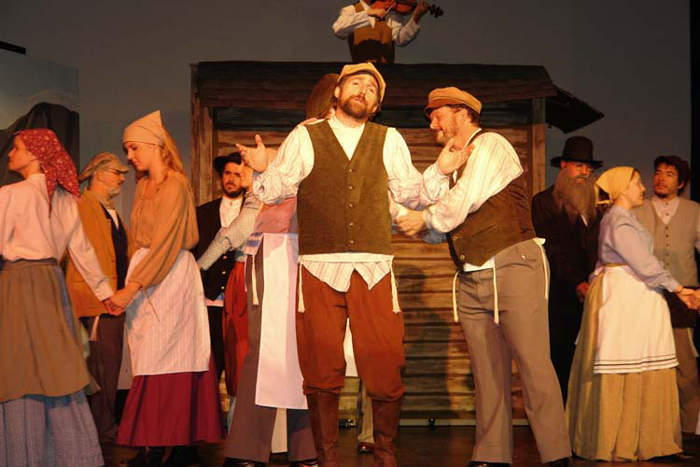
Fathers and Sons: Brown, grey, cream, or tan pants (no white), colored button down shirt with a vest or jacket (see pictures below), ivy or gatsby hat, and boots (or you can get costume boot covers that make a solid shoe look like a boot).
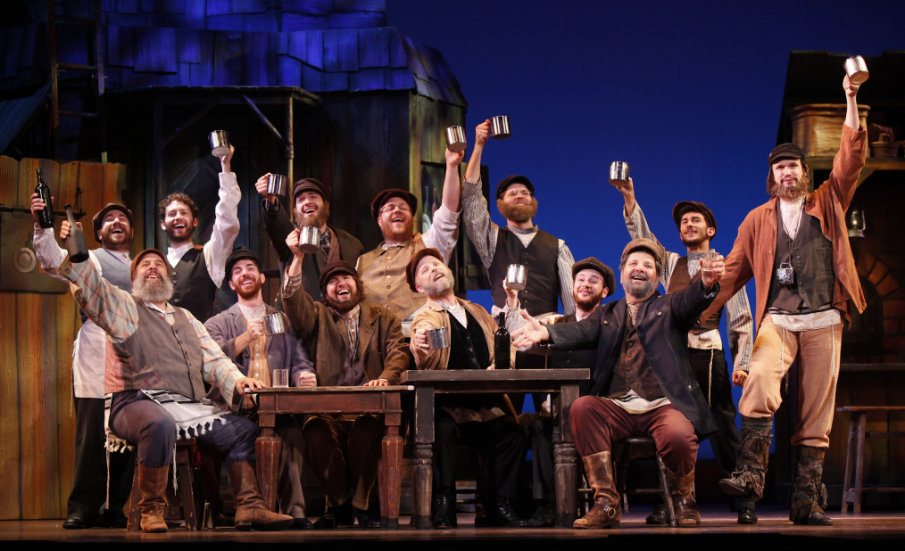
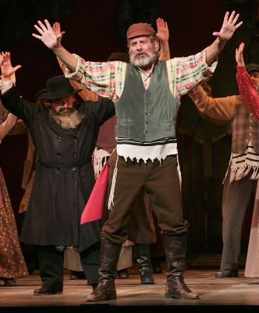

Rabbi: Long black coat with a white shirt collared underneath, black pants, and black shoes. I’ll have a hat for you.

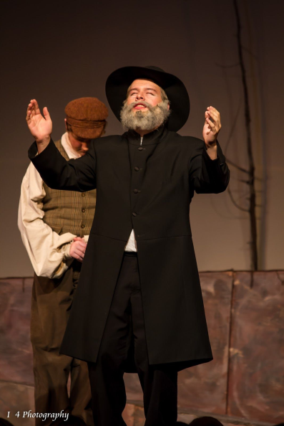

Russians: black button down, black pants and black boots (or pirate-looking boot covers). I’ll get you red sashes and hats.

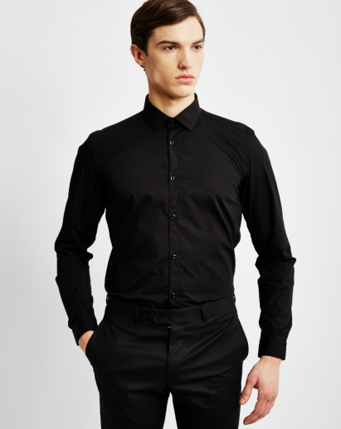
Grandma Tzeitel: White tunic, shawl, and head covering (all white). We have a cane and a nightgown for you.
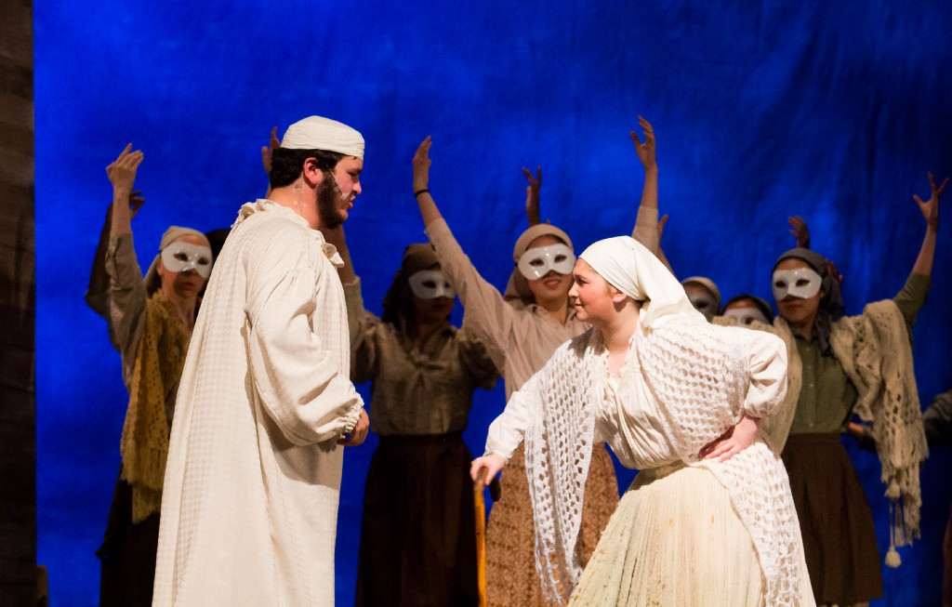

Tevye and Golde: Long, white old fashioned nightgowns for “The Dream.” I’ll have nightcaps for you.
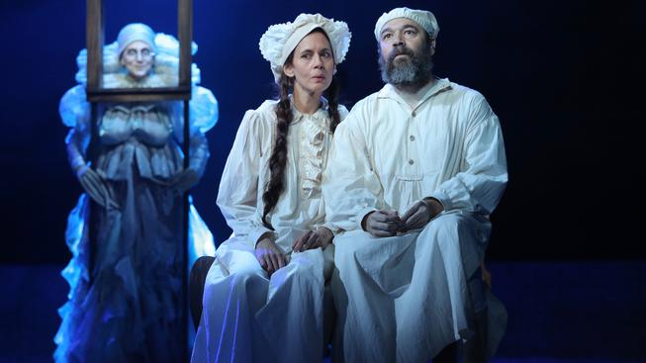
Fruma Sarah: I may have an old wedding dress that we can mess up for you. Otherwise, grey sheets can be used to create your look. Sew the sides together (leaving space for your arms) and wrap a belt of rope, tassel, or pearls, if you want to get really creative, around it. The makeup will do the rest of the work.
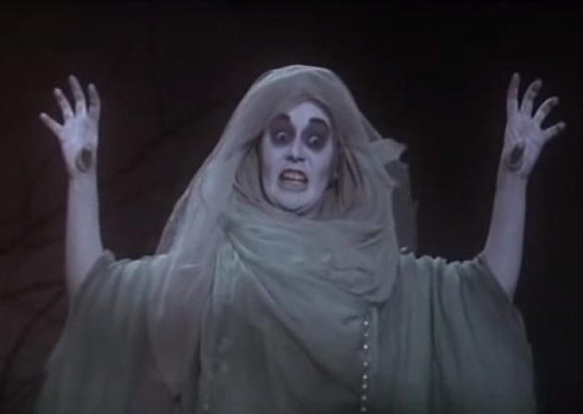
Tzeitel and Motel: You’ll need to change into a long black coat (Motel) and wedding dress (Tzeitel) for the wedding. Tzeitel, I’m going to search for a wedding dress, but you should keep an eye out too.

