All Shook Up Costumes
*Search local thrift shops for bargains. DO NOT spent a lot of money on these things. If there are monetary issues at home, please see Ms. Levy for assistance.
MEN and BOYS: They would wear a pair of slacks (pleated suit pants) with a button down shirt, a tie (long or bow), maybe a sweater over the shirt, and dress shoes (loafers)
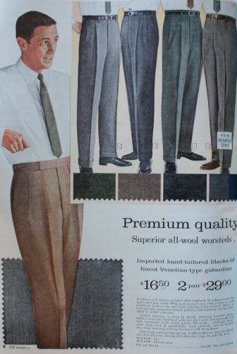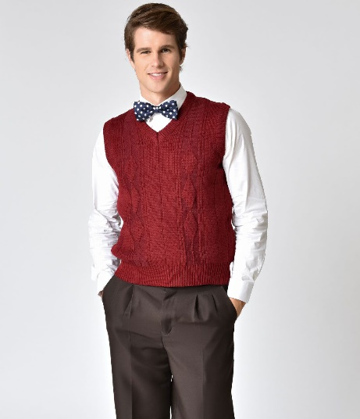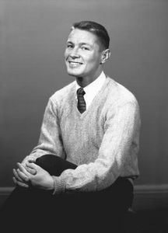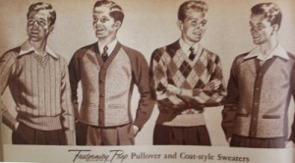
WOMEN and GIRLS: A flared dress OR pedal pushers with a tucked in, plain-colored top with character shoes or a low heel (nude or black)
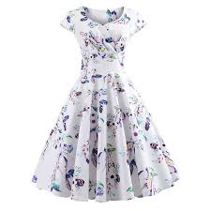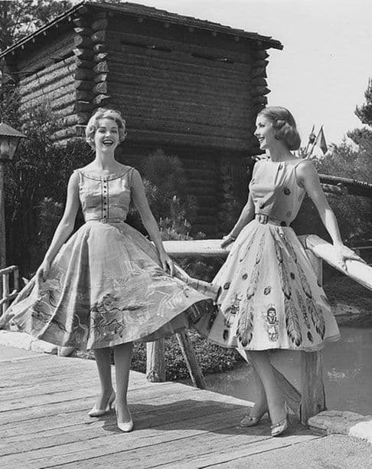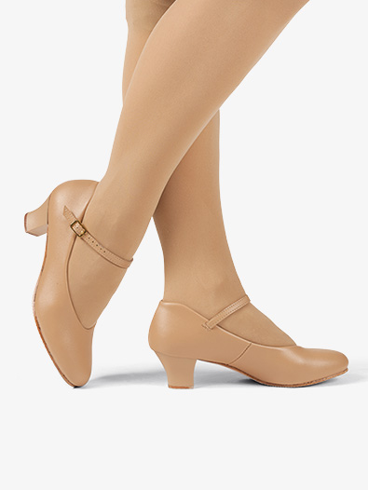

“Jailhouse Rock” ensemble: black jeans or pants with striped black and white t-shirt (t-shirt will be provided), white socks and black shoes (Chad, you will switch from this to jeans, a white t-shirt, and a leather jacket. The jacket will be provided)
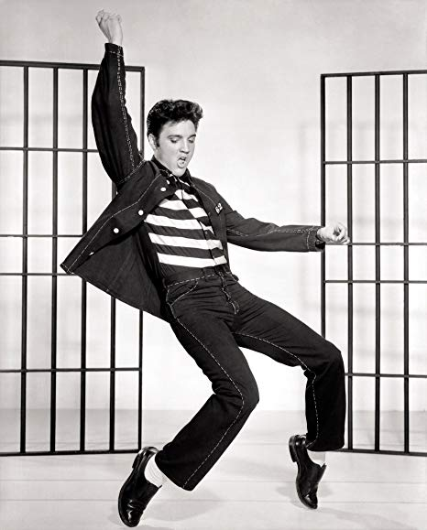
“Devil in Disguise” ensemble: black leggings, red t-shirt (for devils) or white t-shirt (for angels). Devil horn and halos will be provided.
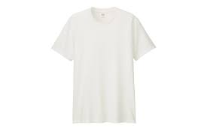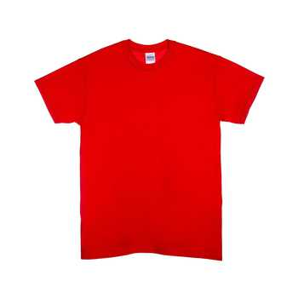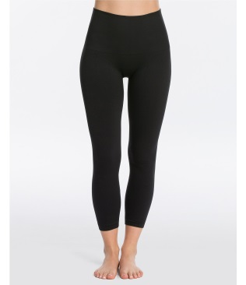
“Don’t Be Cruel” ensemble: white leggings with a long-sleeve white t-shirt (the rest of the costume will be provided)
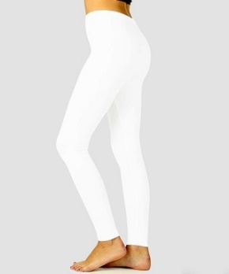
Sheriff Earl: navy suit with a navy button-down shirt and dress shoes (police badge and hat will be provided)
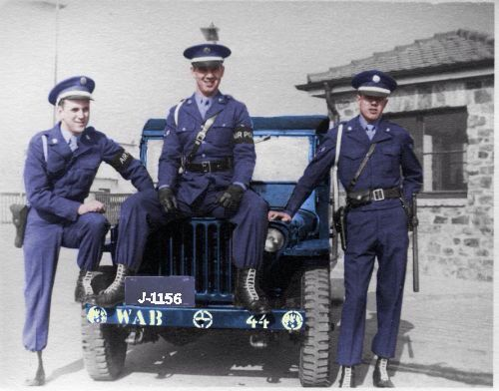
Warden: khaki button down shirt and black pants (after “Jailhouse Rock” you will change into the men’s costume)
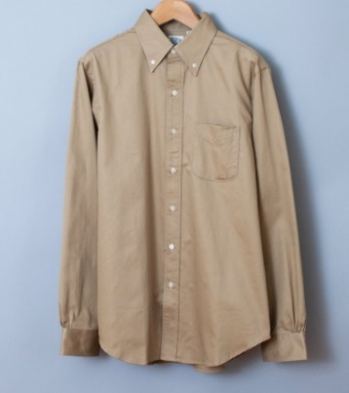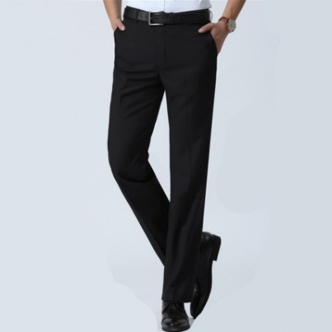
Matilda: Suit or sheath dress with character shoes or low heel
