Addams Family (Grandma, Wednesday, Gomez, Morticia, Lurch, Fester, and Pugsley): Grandma is in a tattered black dress with black tights and boots. She should have no skin exposed. Wednesday wears a black dress with a Peter Pan collar, black tights, and black or white boots. She will also need a yellow version of the same dress for the scenes with Alice. Gomez wears a black and white pinstriped suit with a tie (bowtie or necktie) and black shoes. Morticia wears a form-fitting black gown with tatters coming off of the sleeves. The dress should be floor-length, so low heels or character shoes are fine. Lurch wears a tuxedo or black suit that looks tuxedo-like with black shoes. Fester wears a big black floor-length coat that covers him from neck to feet. Pugsley wears a black and white striped t-shirt and black shorts with high black socks and black shoes. Cousin It is completely covered by hair but wears glasses and a beret.
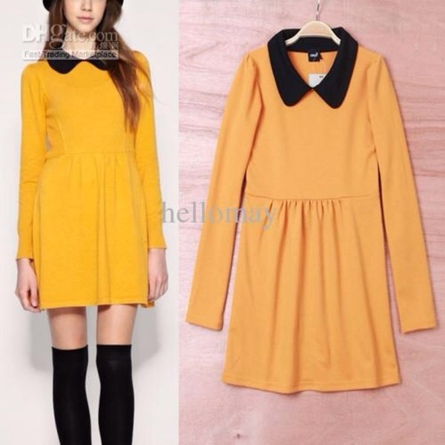
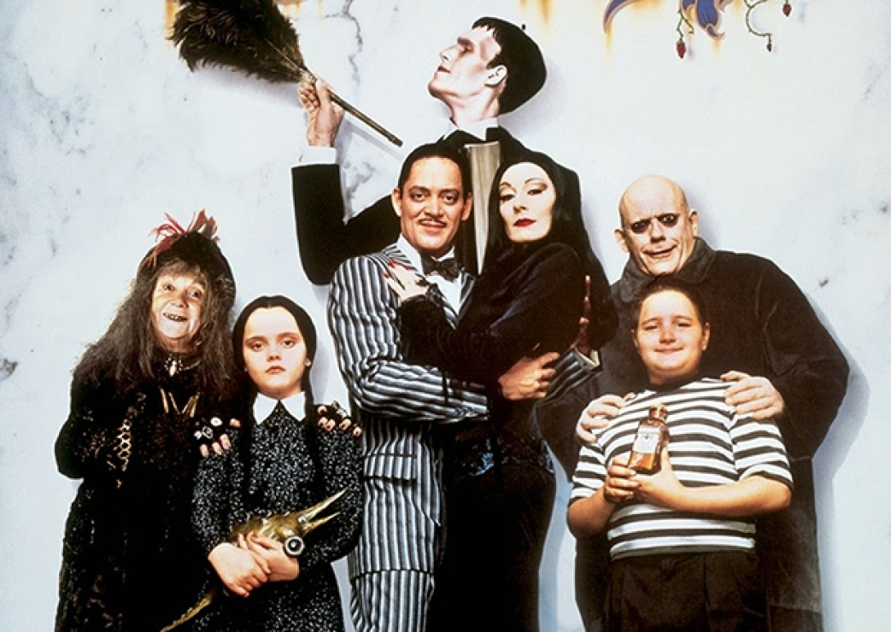
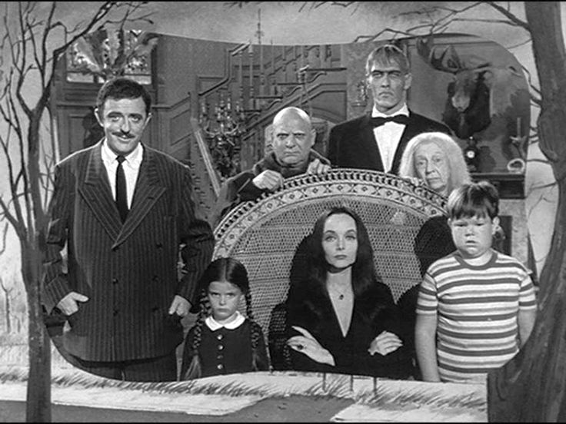

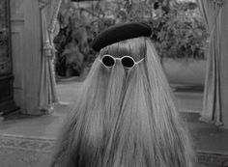

Addams Ancestors: White or light grey dresses and suits, tights, shoes, etc. Look for things from different eras (since you’re dead that means you might’ve lived in the 1920s, 1950s, 1800s, etc., so you don’t want your outfit to look modern). You are supposed to be dead, so the dustier looking, the better.
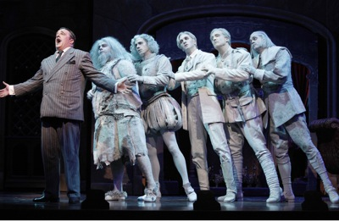
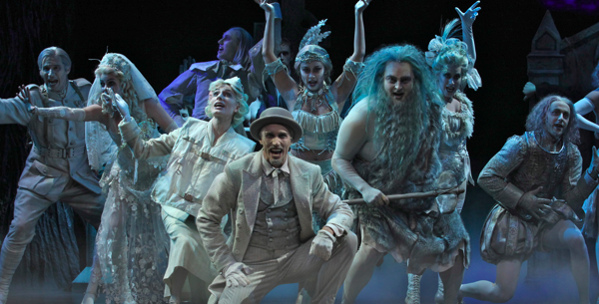

Beineke Family (Alice, Mal, and Lucas): Alice wears a bright yellow dress and needs a trench/raincoat. Mal wears a suit and also needs a trench/raincoat. Lucas should look like he’s trying to impress his girlfriend’s family – khakis, tie (bow or necktie), blazer, shoes or sneakers.



